ISTE 730 - Foundations of IoT

Lab 8 - Ultrasonic Radar

[**Introduction**](https://docs.google.com/document/d/1Y9_bqXMgaug_S4leBWCsFXjfdAdbD66jekvyYPBFc-U/edit#heading=h.9x9ku77uevre)[**1**](https://docs.google.com/document/d/1Y9_bqXMgaug_S4leBWCsFXjfdAdbD66jekvyYPBFc-U/edit#heading=h.9x9ku77uevre)

**Exercise 2 - Window Blinds** **3**

Sample Output 5

**Submission** **6**

# Introduction

RADAR, which stands for radio detection and ranging, is a radiolocation system that usesradio waves to determine the distance and angle of the objects present in its range.

A radar system consists of a transmitter producing waves, a transmitting antenna, and a receiving antenna. Radio waves from the transmitter reflect off the objects and return to the receiver, giving information about the objects' locations.

The below exercise simulates the real world RADARS with limited capabilities.

# Hardware required:

* Grove servo motor

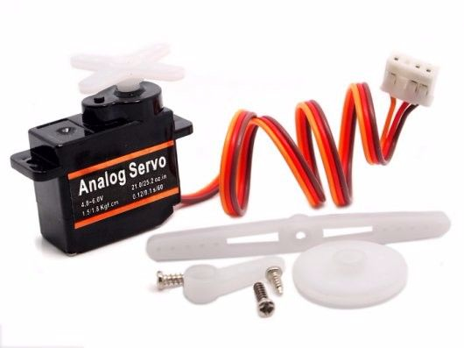

* Ultrasonic distance sensor.

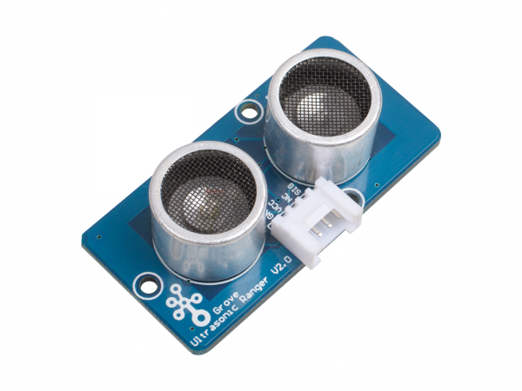

* Double sided Tape (will be provided by TA).

# 

# 

# 

# Software required

* Java Runtime Library from oracle.

Download and install: <https://www.java.com/en/download/manual.jsp>

* A graphical library and IDE called “Processing”.

Download link: <https://processing.org/download>

Note: If you run into any issues downloading or installing the above applications, please contact TA.

# Exercise 1

* Write code in the arduino, to output the distance readings from the ultrasonic sensor.
* The servo motor should sweep from 0 to 180 deg and from 180 to 0 deg.
* When the servo motor should rotate continuosly each degree, the ultrasonic sensor should fetch the distance readings, i.e for 180 degrees of rotation there should be 180 readings from the sensor, hence the total of 360 readings for the complete servo sweep cycle.
* There should be a delay of 40 ms between each degree rotation(consider the motor rotates from 5 deg to 6 and the ultrasonic sensor gives the distance reading, then there should be a wait time of 40 ms for next rotation and sensor read.)
* The code should output the results in pair of angle and sensor readings separated by comma and end with full stop (“angle,distance.”) and each result should be in the same line without and spaces for example (“angle1,distance1.angle2,distance2.angle3,distance3.”), because the visualization code is designed to accept results as input in the above format
* In the arduino IDE go to Tools and select port to see the port name used by the computer to communicate with the arduino and note it down as we need it for future reference.

macOS machines

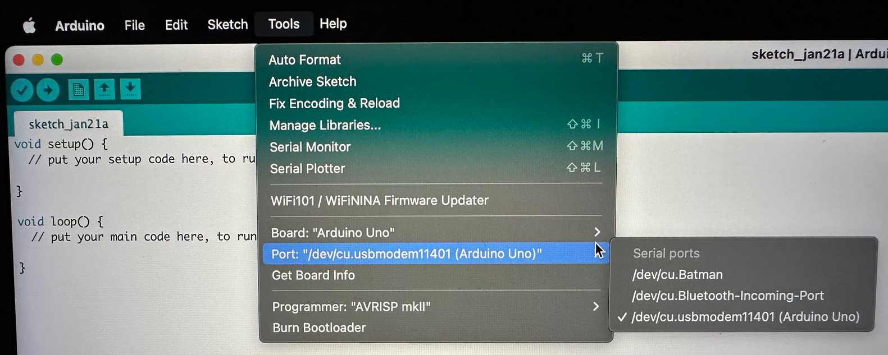

Note down the port name as “/dev/cu.usbmodem11401” (differs for each different computer)

Windows machines

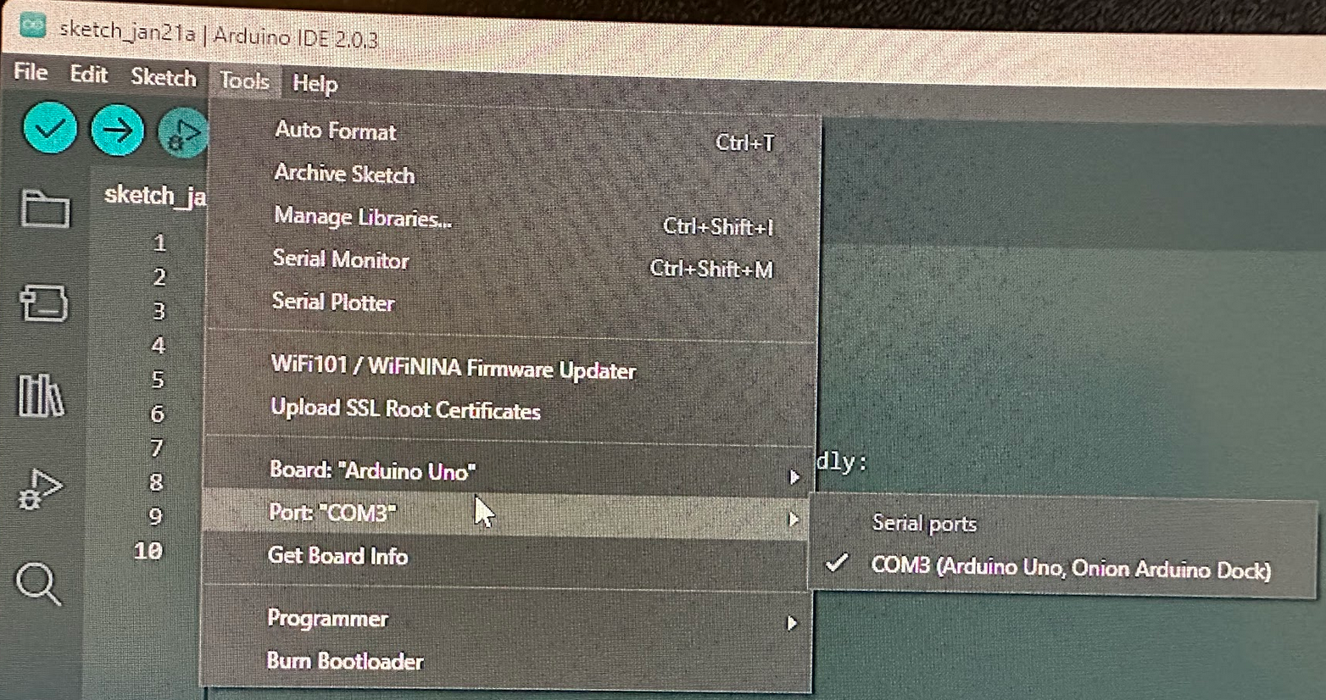

Note down the port name as “COM3” (differs for each different computer).

* The output of your arduino code should match the below format.



* Download the file containing code for visualization named “radar”.
* Open the “processing” IDE and open the code file in the IDE.
* Edit the line 19 containing code “ myPort = new Serial(this,"COM3", 9600);”, put your port name in place of COM3. and save it.
* Attach the double sided tapes, one at the bottom of servo motor to any rigid surface and one on the top of the rotating surface and stick the ultrasonic sensor perpendicular to it as shown below.

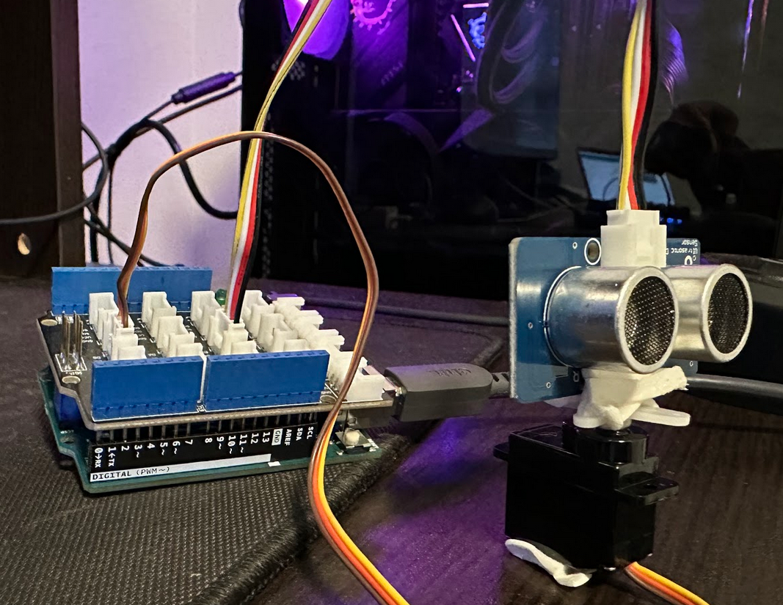

* When all the connections are made, in the arduino IDE verify and upload your code to the arduino device, and close the IDE to avoid interference with the other IDE.

Now open the Processing IDE and run the code and if the output of arduino matches the graphical visualization window opens and shows objects detected in its 180 degree view.

* Note: The range of the sensor is limited to 155 cm in the program to achieve accuracy. If any object is above 155 cm distant from the sensor it will not show in the radar.

# Output

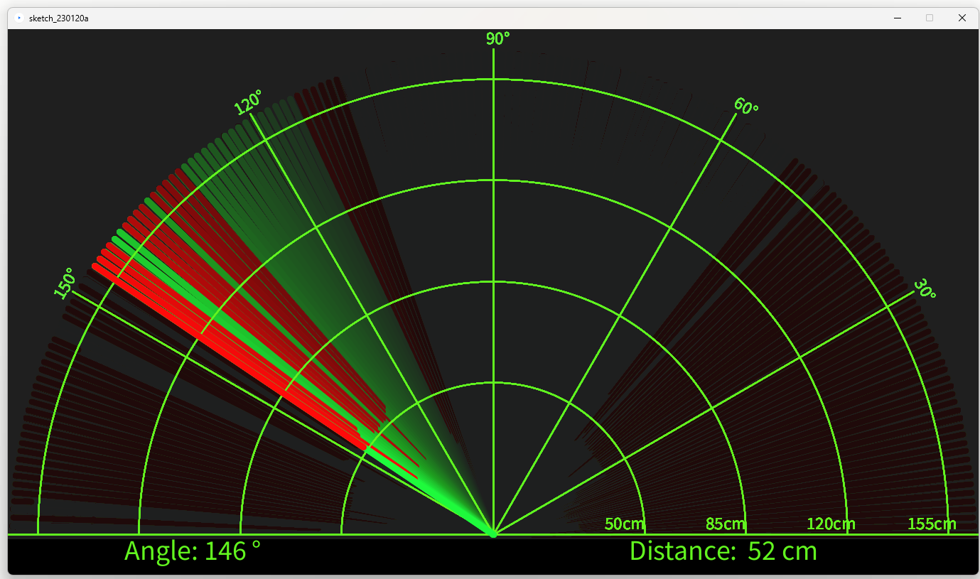

# Submission

Make sure that any functions in your code contain a brief description, parameters and return value descriptions.

You must submit the following on myCourses:

* PDF containing screenshots of exercises, Screenshots should include your name.
* Exercise 1 - Demonstration Video.
* Exercise 1 - Code.

**ZIP Folder Structure**

-- Lab8 - <First Name> <Last Name>

-- Lab5.pdf

-- ex1

--ex1.video_format

-- ex1.ino